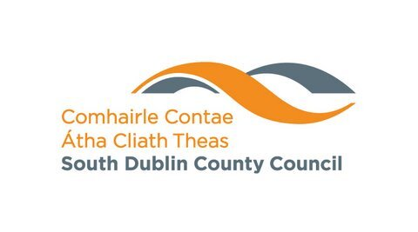

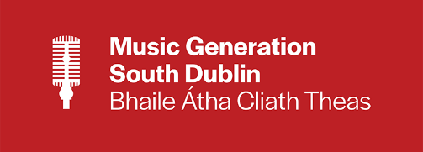

Music Generation South Dublin

Music Generation South Dublin is part of Music Generation, Ireland’s National Music Education Programme which transforms the lives of children and young people through access to high-quality, subsidised performance music education. Locally, Music Generation South Dublin is supported and funded by South Dublin County Council, Dublin and Dun Laoghaire ETB and Dublin West Education Centre.

Established in 2014, Music Generation South Dublin provides a range of performance music education programmes for children and young people throughout the area. These include:

      - Community Hubs in Citywest, Kingswood, Rathcoole and Clondalkin.
      - Instrumental classes in Violin, Keyboard, Ukulele, Guitar, Bass Guitar and Drums.
      - Vivo Classes are group classes with 4-6 students in each class. These classes are designed for young beginner musicians aged 7-9 years old.
      - Vocal clubs and Vocal Hubs.
      - Music Generation South Dublin offers early years music classes for babies and adults in partnership with SDCC Libraries.
      - Primary School Programmes which include: Early Years Primary, Ready Steady Sing and Ready Steady Play.
      - Secondary School Programmes which include: Suburban Sounds, NOISE Music, Choral Programme, Instrumental Programme.
      - Instrument Bank.

Further information about Music Generation South Dublin is available at:

- http://www.musicgenerationsouthdublin.ie/
- https://www.facebook.com/MusicGenSD
- https://twitter.com/MusicGenSD

BACKGROUND INFORMATION – MUSIC GENERATION

Music Generation is Ireland’s National Music Education Programme that transforms the lives of children and young people through access to high-quality, subsidised performance music education. Initiated by Music Network, Music Generation is co-funded by U2, The Ireland Funds, the Department of Education and Local Music Education Partnerships (LMEPs) in which Education and Training Board and Local Authorities play a lead role.

Its genesis stems from the combined philanthropic support of U2 and The Ireland Funds to seed-fund phased implementation of Music Network’s Feasibility Study Report: A National System of Local Music Education Services.

Phase 1: 2010 - 2015
Formed with the aid of a €7m philanthropic donation from U2 and The Ireland Funds, Phase 1 of Music Generation established eleven LMEP Areas: Louth, Mayo, Sligo, Cork City, Laois, Wicklow, Carlow, Limerick City, Offaly/Westmeath, Clare, and South Dublin.

Phase 2: 2016 - 2021
Phase 2 was enabled by a further €6.3m philanthropic donation from U2 and The Ireland Funds to establish the programme in nine additional LMEP Areas: Cavan/Monaghan, Dún Laoghaire-Rathdown, Galway City, Galway County, Kilkenny, Leitrim, Roscommon, Waterford and Wexford.

National Expansion
In December 2017, Government announced its commitment to support the expansion of Music Generation to all nine remaining areas of the country by 2022: Kerry, Kildare, Longford, Meath, Tipperary, Dublin City, Fingal, Limerick County and Cork County.

For further information visit: www.musicgeneration.ie

“Music Generation focuses on the provision of performance music education across the breadth of vocal and instrumental music making, creating, learning and performing in the broadest possible range of genres and styles of music. This includes pedagogical approaches and practices appropriate to particular musical cultures and traditions and is delivered by professional Musician Educators across a range of teaching, learning and participation contexts.” Music-Generation-Strategic-Plan-2022-2026

